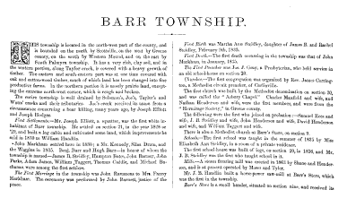THIS township is located in the north-west part of the county, and is bounded on the north by Scottville, on the west by Greene county, on the south by Western Mound, and on the east by South Palmyra township. 'It has a very rich, clay soil, and in the western portion, along Taylor creek, is covered with a heavy growth of timber. The eastern and south-eastern part was at one time covered with Oak and cotton-wood timber, much of which land has been changed into tine productive farms. In the northern portion it is mostly prairie land, except mg the extreme north-west corner, which is rough and broken.

The entire township is well drained by Solomon’s, Joe’s, Taylor’s and Watts’ creeks and their tributaries. Joe’s creek received its name from a circumstance concerning a bear killing, many years ago, by Joseph Elliott and Joseph Hodges.

*First Settlements*—Mr. Joseph Elliott, a squatter, was the first white in habitant of Barr township. He settled on section 21, in the year 1828. or ’29, and built a log cabin and cultivated some land, which improvements he sold in 1830 to William Handlin.

~John Markham settled here in 1830; a Mr. Kennedy, Silas Drum, and the Wiggins in 1835. Benj. Barr and Hugh Barr-in honor of whom the township is named—James B. Steidley, Hampton Bates, John Barnett, John Parks, Adam James, William Taggert, Thomas Coddle, and Michael Buchanan were among the first settlers.

*The First Marríage* in the township was John Rummons to Mrs. Fanny Markham. The ceremony was performed by John Barnett, justice of the peace.

*First Birth* was Martha Ann Steidley, daughter of James B. and Rachel Steidley, February 9th, 1835.

*First Death.*—The first death occurring in the township was that of John Markham, in January, 1835.

*History of Macoupin County, Illinois: And Biographical Sketches of Some of its Prominent Men and Pioneers.* Philadelphia: Brink, McDonough & Co., 1879. Print.

Database: WorldCat

Found on Google Books at: <https://books.google.com/books/content?id=L01EAQAAMAAJ&pg=PA156&img=1&zoom=3&hl=en&sig=ACfU3U351VRgveNUOo2gBaffEIf8gnHhPQ&ci=126%2C980%2C356%2C115&edge=0>